**Testing the Code:**

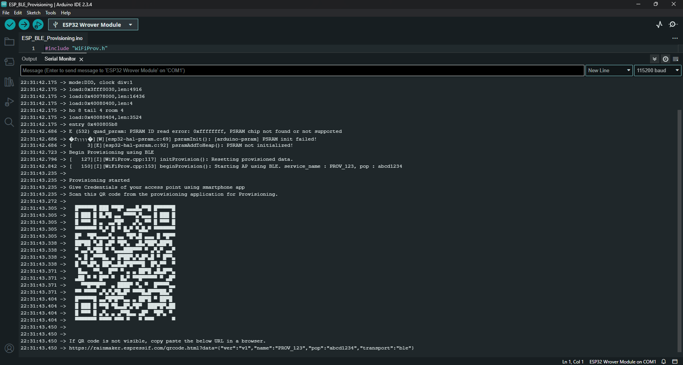After uploading the code to the ESP32, open the Serial Monitor at a baud rate of 115200. Press the ESP32 RST button, so it starts running the code.

Now, open the Espressif WiFi Provisioning App on your smartphone and click on **Provision Device**. It has the option to scan the QR code, but I couldn’t make it work. Click on “**I don’t have a QR code**“.

It will list all Bluetooth Devices within its range with the “**PROV_**” prefix. Our code sets the ESP32 as a BLE Device called “**PROV_123**“—click on that device.

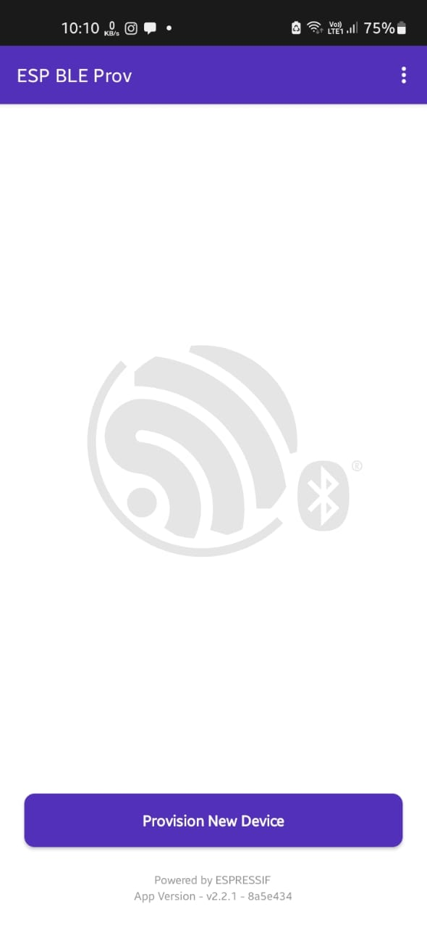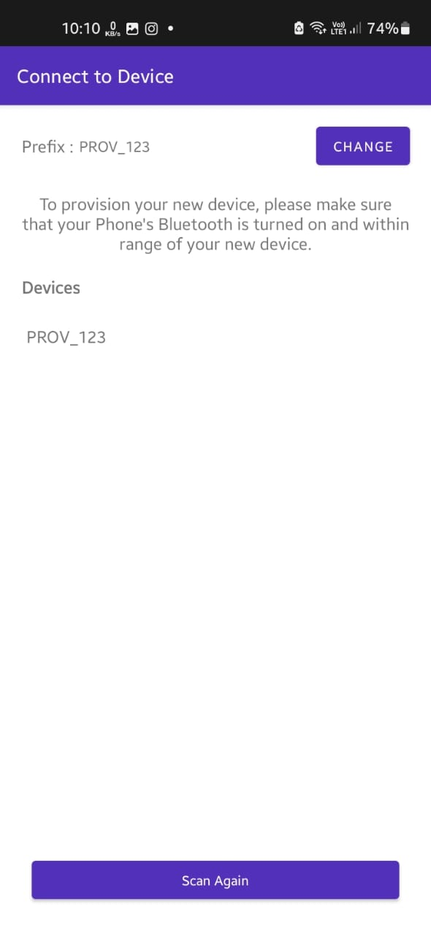

Then, you need to enter the proof of possession—it must be the same used in the code. We’re using the default values, so it will be *abcd1234*. After, it will list all Wi-Fi networks within its range (if it doesn’t list your network, you may need to enter it manually by clicking on “Join Other Network”).

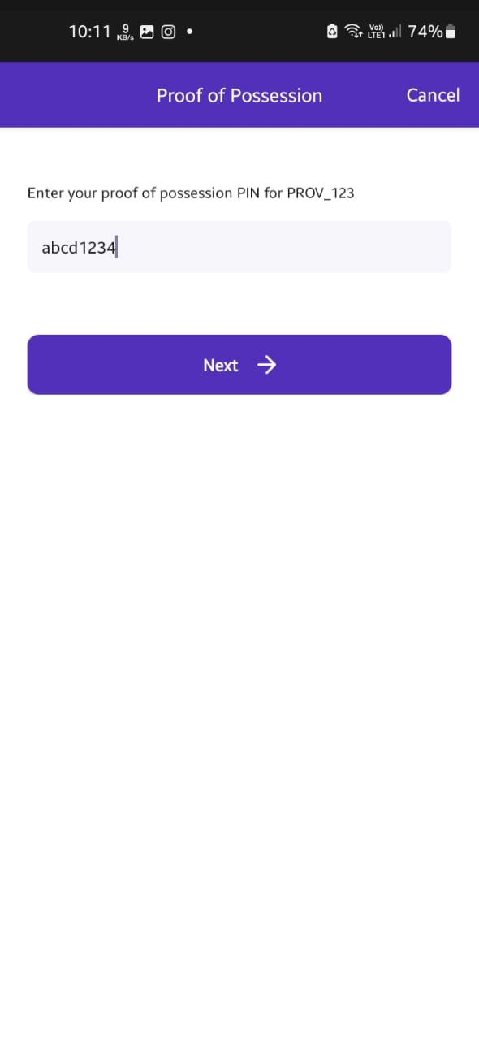

Finally, enter the password for your Wi-Fi network and click Connect. The Wi-Fi credentials should be sent to the ESP32 after a few seconds.

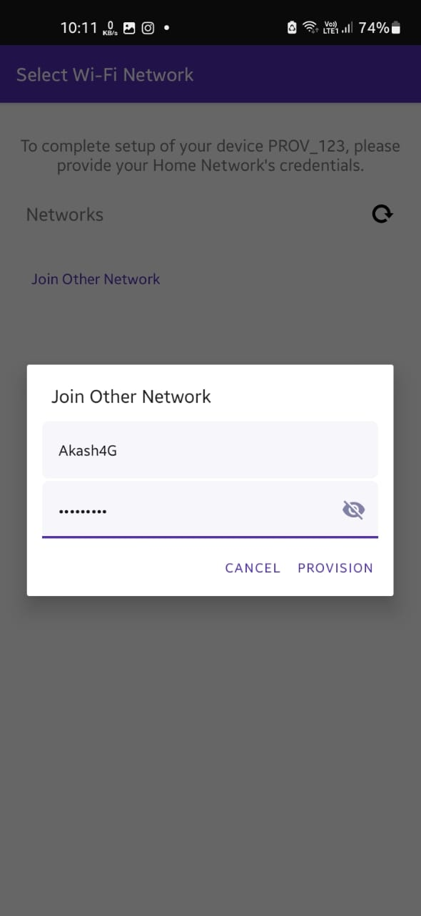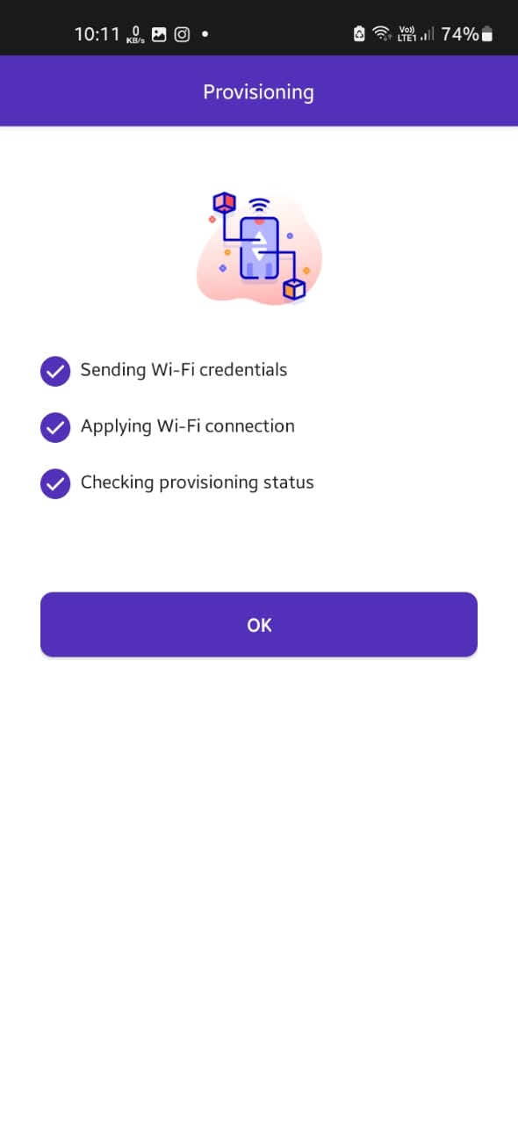

On the Serial monitor, you can see that the ESP32 received the Wi-Fi credentials and connected successfully to the network (it printed its IP address on the network it connected to).

